Overview
The Design Rationale is intended to provide designers and maker information about the design process and design decisions behind the development of the Shrub Hub, a cheap, easy to assemble switch access hub.
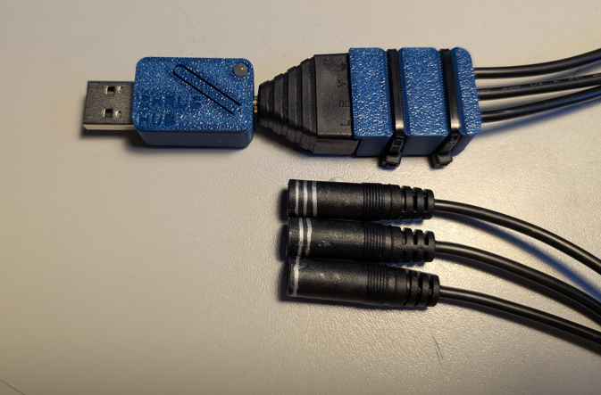

Contents
Overview 1
Introduction 2
Requirements 3
Goals 3
Functional Requirements 3
Non-functional Requirement 3
Constraints 3
Research 3
Commercially Available Options 3
Swifty 3
DIY / Maker-Friendly Options 4
Rocket Switch 4
Prototyping 5
Initial Prototype 5
Physical Component / Enclosure 5
Electrical Components 6
Code Structure / Function 7
Prototype Decisions 7
Testing 7
Test Methods 7
Test Switches 7
Test Results 7
Detailed Design 7
Physical Component / Enclosure 8
Electrical Components 8
Code Structure / Function 9
Opportunities for Improvement 9
Physical Component / Enclosure 10
Electrical Components 10
Code Structure / Function 10

Introduction
The original design came from an Adafruit learning guide by Chris Young and Bill Binko. The device in the learning guide was similar to the Rocket Switch by MMC, and did not require a custom PCB to be ordered and could be assembled without soldering. After test building the described device, it was decided to document and publish it with some changes as a lower cost, easier to build version of the Rocket Switch.
This device provides low-cost digital switch access to users who require assistive switches to interact with technology. This device is intended for any user that is having difficulty using a digital device and would like to use switch inputs.

Requirements
The goals and requirements outlined here can be used to assess if a device would meet the needs of a user, and determine when a design is sufficient for release.

Goals
G01 | Create a low-cost switch interface
G02 | Create an easy to build switch interface

Functional Requirements
F01 | Device must accept up to two 3.5mm switch inputs
F02 | Device must output HID keystrokes to the connected device

Constraints
C01 | Device cannot use a custom PCB
C02 | Device cannot require soldering

Research
Research was conducted as part of the update for the Switch Interface 101 resource.

Commercially Available Options
Options that can be purchased but not made by a maker.

Swifty
Title / Name of device | Swifty
Link | https://www.orin.com/access/swifty/
Author | Origin Instruments
License | N/A
Cost | $99 USD
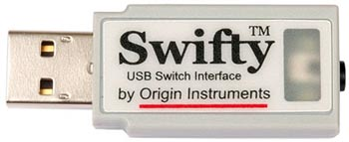
The Swifty is a digital switch interface that can connect up to two 3.5mm switches, or up to three wireless ‘Beam’ switches. It can be used to send keystrokes to a connected device for switch scanning or computer control.
Requirements Met | Requirements Unmet
F01, F02 | G01

Useful Design Features
Using three switches instead of two opens more options for computer control.

DIY / Maker-Friendly Options
Options that can be made by a maker.

Rocket Switch
Title | Rocket Switch
Link | https://www.makersmakingchange.com/s/product/rocket-switch-interface/01tJR000000694SYAQ
Author | Neil Squire Society
License | Attribution-ShareAlike4.0 International
Cost | $50 CAD
Test Build (Y/N) | Y
Add to Library (Y/N) | Y
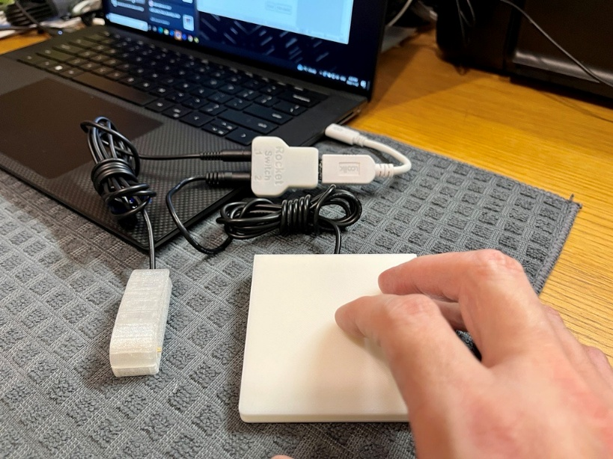
The Rocket Switch is a digital switch interface that accepts up to two 3.5mm switches to send keystrokes to the connected device.
Requirements Met | Requirements Unmet
G01, F01, F02 | C01, C02, G02

Useful Design Features
The modes feature of the Rocket Switch was taken and added to the Shrub Hub.

Prototyping

Initial Prototype
The initial version as published on the Adafruit site.

Physical Component / Enclosure
The enclosure used on the device was provided by Adafruit. The version used was the FDM printed version, although they also provide an SLA compatible version.
The case can be found here.
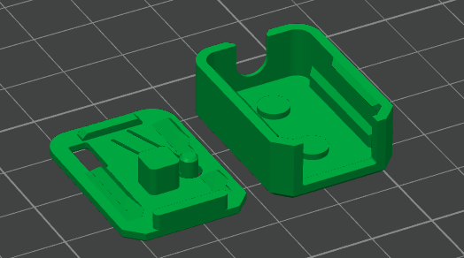

Electrical Components
Part | Image | Price | Link
TRRS Trinkey | 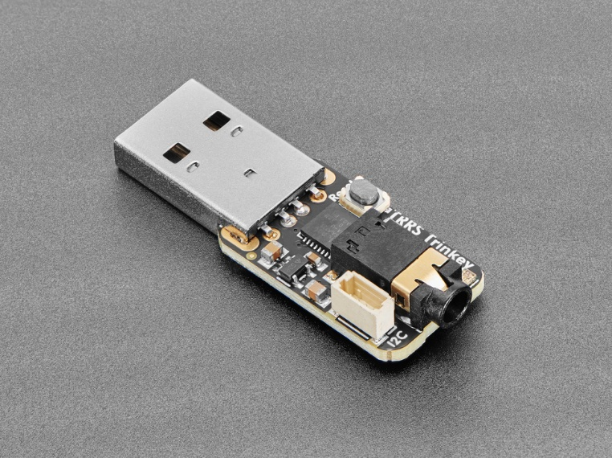 | $9.95 USD | Link
Microphone Splitter Cable | 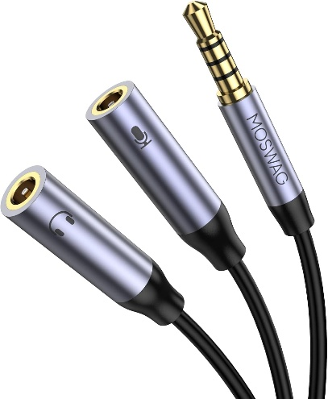 | $10.99 CAD | Link
Stereo to Mono Splitter | 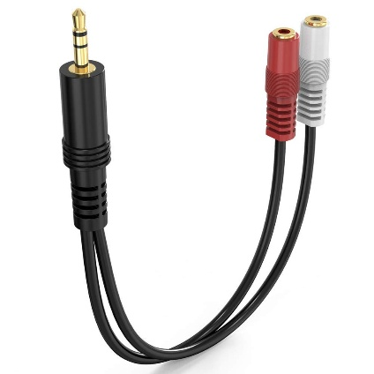 | $9.99 CAD | Link

Code Structure / Function
Code used for the initial version was the supplied code in the project repository called TRRS_Switch_Control on GitHub.
The code scans the connected buttons and determines which output to send depending on the combination of switches pressed. The software recognizes the 3 individual switch presses and has an additional 2 outputs from chorded inputs, with another 2 chords recognized but not implemented.

Prototype Decisions

Prototype | Decision (Abandon, Modify, Proceed) | Justification
Initial Prototype | Modify | Missing some functionality.

Testing

Test Methods

Test Switches
After connecting all switches to the splitter cables, the device was plugged in and tested.

Test Results
Initially, there was an issue where one key was consistently pressed down. This was determined to be caused by the mono TS cable used in the switches being consistently shorted by the microphone splitter cable. As a temporary workaround, the switch was replaced with another switch that used a TRS jack that would not be shorted.
Once the cables were working, it was found that the software worked as described, sending u/d/s/l/r when the correct switch/chord was pressed.

Detailed Design
The current version of the device is the TRRS Trinkey with the 3D printable Adafruit enclosure. A splitter is used to break out each ring of the TRRS jack, with two different splitter options available. The code was modified to make it more similar to the Rocket Switch, with 4 different operating modes.
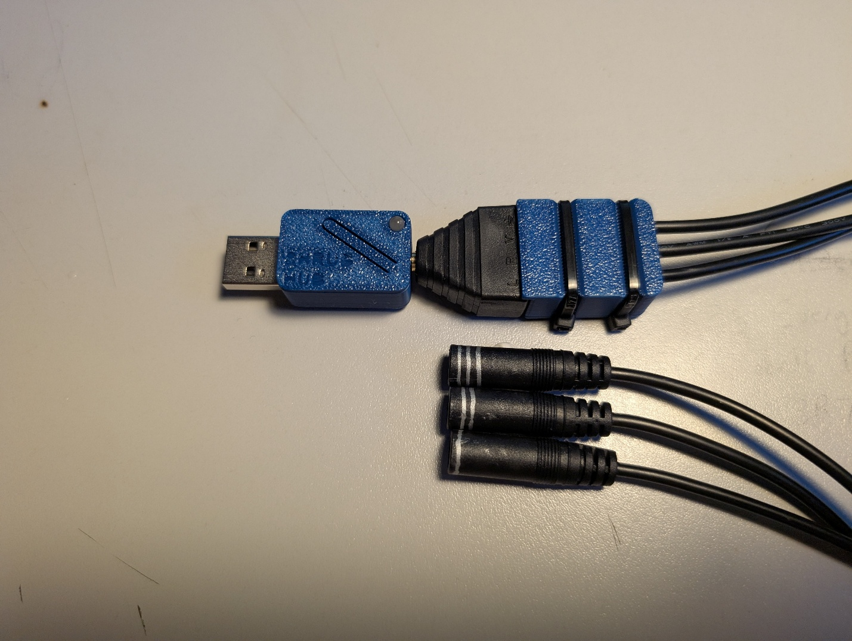

Physical Component / Enclosure
A new enclosure was developed that has the name of the device on it that includes a light pipe and covers the unused i2c port.

Electrical Components
After the issue with the mono cable switches shorting on the microphone splitter, an alternate splitter cable was created using a TRRS terminal jack and three pre stripped female mono cables. This option requires slightly more assembly, but still does not require soldering. It is cheaper to build than the commercial splitter version, and gets even cheaper when built in bulk.
Part | Image | Price | Link
Single Build
TRRS Terminal | 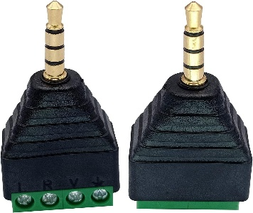 | $6.58/2 pack  $3.28 Each | Link
Female Mono Cable | 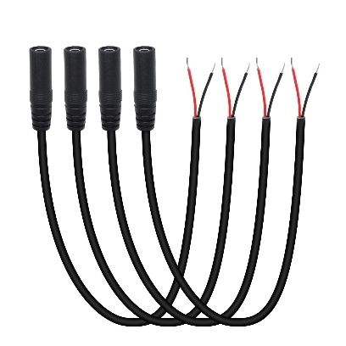 | $10.99/4 pack  $2.75 Each | Link
Bulk Build
TRRS Terminal | 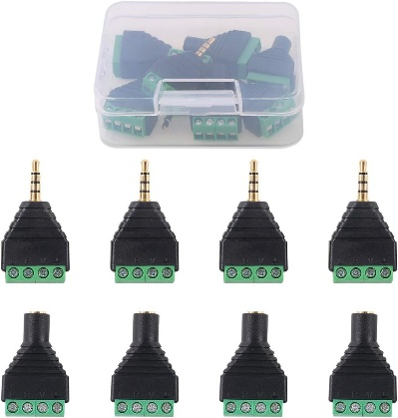 | $14.93/8 pack  $1.86 Each | Link
Female Mono Cable | 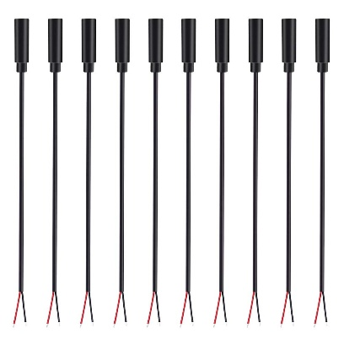 | $20.22/10 pack  $2.02 Each | Link

Code Structure / Function
The code was modified slightly to add four different operational modes, differentiated by the colour of the onboard neopixel light. The added operational modes are similar to the ones in the Rocket Switch interface, with the addition of a mode requested by a clinician that has the unused function keys to allow for shortcuts/hotkeys.
The different modes allow the user to send Enter/Space/Tab/Backspace/Esc, F1-F5, 1-5, and F13-17. The button hold timeout function was adapted to when the user holds any key for longer than 4 seconds, it switches to the next operational mode.

Opportunities for Improvement

Electrical Components
- Better documentation on how to determine which input goes to which ring on the trrs/which switch input
- Examine options for a better method of labeling the switch inputs than the rings of silver sharpie.

Code Structure / Function
- The main improvement that needs to be made is the addition of a settings mode like in the Rocket Switch.
- The mode could be saved so it does not need to be reselected after unplugging the device.
- Detect when only the stereo splitter is in use and disable the third switch input so it is not constantly pressing
  - This could be extended to disable any input that is held for too long and maybe send an error?
  - Detect when a cable is plugged/unplugged to allow it to scan for shorted inputs and

